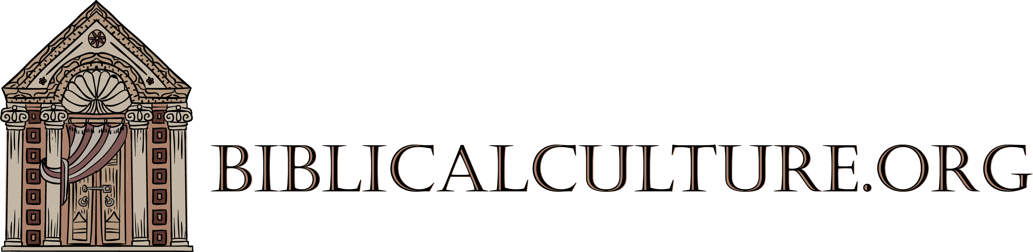

Scripturist Program Application

Name:

Phone Number:

Email:

Address:

What Biblical books or topics of Biblical culture might you be interested in studying as you pursue your Scripturist certificate? Are there any particular classes you might want offered?

What type of Scripturist projects do you envision yourself undertaking? Examples might be a scholarly research paper, an oral presentation, a curriculum for a Church or Synagogue, or a creative work of your choosing, e.g., music, art, poetry, etc.

Do you plan on studying in our live courses or with our recordings?

21 Scripturist projects in 21 months – plus two projects – is a daunting endeavor. Do you think you will be able to pursue this project until the end?

